In-Cabin Passenger Classification using mm-Wave Radar Technology

*Final-Year Project Report by*

Raiha Raees

Areeba Mehboob

Syeda Zayra Batool

*Supervised by*

Dr. Nosherwan Shoaib

Dr. Hammad M. Cheema

In partial fulfillment of the requirements for the degree Bachelor of Electrical Engineering (BEE)

School of Electrical Engineering and Computer Science

National University of Sciences and Technology

Islamabad, Pakistan

10th May, 2023

**DECLARATION**

We hereby declare that this project report entitled “*SafeAuto: In-Cabin Passenger Detection using Millimeter-Wave Radar”* submitted to the Department of Electrical Engineering, is a record of an original work done by us under the guidance of supervisor Dr. Nosherwan Shoaib and co-supervisor Dr. Hammad M. Cheema and that no part has been plagiarized without citations. Also, this project work is submitted in the partial fulfillment of the requirements for the degree of Bachelor of Electrical Engineering.

|  |  |  |
| --- | --- | --- |
| **Team Members** |  | **Signature** |
| Raiha Raees |  | ______________________ |
| Areeba Mehboob |  | ______________________ |
| Syeda Zayra Batool |  | ______________________ |
| **Supervisors** |  | **Signature** |
| Dr. Nosherwan Shoaib |  | ______________________ |
| Dr. Hammad M. Cheema |  | ______________________ |

**Date**: 10th May, 2023

**ACKNOWLEDGMENTS**

We are grateful to everyone who was involved in this thesis, including:

* Our advisor, Dr. Nosherwan Shoaib from The Research Institute for Microwave and Millimeter-Wave Studies (RIMMS) for his valuable insights.
* Our co-advisor, Dr. Hammad M. Cheema from the School of Interdisciplinary Engineering & Science (SINES) for his unrelenting support and guidance.
* Acconeer for providing the radar modules and lens for this project.

# Abstract

According to noheatstroke.org, 942 children have died due to Pediatric Vehicular Heatstroke (PVH) since 1998 in the US with average number of U.S. child heatstroke fatalities per year 1998-2022 being 38. This project aims to prevent such incidents of children being accidentally left in a locked car by developing a system that can detect the presence of a child in a switched off vehicle. The system uses an Acconeer XM112 radar module, integrated with a Raspberry Pi 4, to detect the presence of a child in the car. When the car is switched off, the system will begin monitoring the interior of the car using the XM112 module, which uses radar technology to detect the presence of objects. The module will take the IQ reading which will then be processed in the Raspberry pi 4b to calculate the breathing rate. The KNN trained ML model will then classify the passenger as a child or an adult and then send a notification to the caregiver's phone, alerting them to the presence of the child. The overall accuracy is 95.48%.

Our project measures breathing rates via a non-invasive device which is more convenient as breathing rates are generally measured by manual counting, which can be very inconvenient and has room for human error.

Now that we have successfully accomplished our goal of ensuring children’s well-being in an enclosed cabin, we can further expand this project for sole medical purposes for children and adults as well.

# Table of Contents

Abstract 4

Table of Contents 5

List of Figures 7

Introduction 8

1.0 Vehicular Pediatric Heatstroke 8

1.1Breathing rate 9

1.2 Methods of breathing rate monitoring 9

1.3 Health concerns of millimeter-wave radar 10

1.4 Aims of SafeAuto 11

Literature Review 12

2.0 Existing radar-based methods 12

2.1 CW Radars 13

2.2 FMCW Radar 14

2.4 Millimeter-wave radar 15

Problem Definition 17

Methodology 19

4.1 Radar-based motion tracking 19

4.2 Signal processing 22

4.3 Machine Learning Model 23

4.2 Breathing Rate detection 24

Implementation and Testing 26

5.1 System level diagram 26

5.2 Radar equipment and tools 27

5.3 Further equipment and tools 28

5.4 Experimental setup 29

5.5 Control variables 31

5.6 Statistical Analysis 32

5.7 Raspberry Pi GUI 33

5.8 Notifying the User 33

5.9 Cost Analysis 33

Results and Discussion 34

6.1 Evaluation of respiration rate readings 34

Conclusion and Future Work 37

Appendix A 38

References 39

# 

# List of Figures

Figure 1.1: Pediatric Heatstroke Data (1998 through 2022 :............................................................................ 7

Figure 4.1: No object detected: ....................................................................................................................... 18

Figure 4.2: Object detected at 0.281m ............................................................................................................ 19

Figure 4.3: Coherent I/Q demodulation, wo being the frequency of the local oscillator…………………………….…20

Figure 4.5: Amplitude and phase data…………………………………………………………………………………………….……………21

Figure 4.6: Signal processing flowchart…………………………………………………………………………….22

Figure 4.7: Decision boundary………………………………………………………………………………………….23

Figure 4.8: Chest movement signal…………………………………………………………………………………..24

Figure 5.1: System Level Diagram……………………………………………………………………………………..25

Figure 5.2: (a) Xm112 front and back (b) XB112 board………………………………………………………26

Figure 5.3: LH112 holder and lenses………………………………………………………………………………….27

Figure 5.4: Raspberry pi 4 B……………………………………………………………………………………………….28

Figure 5.4(a): Experimental Setup for SafeAuto…………………………………………………………………29

Figure 5.4(b): Experimental Setup for SafeAuto…………………………………………………………………29

Figure 5.5: Data collection and testing……………………………………………………………………………….31

Figure 6.1: Results of signal processing………………………………………………………………………………34

Figure 6.2: Results of Machine Learning…………………………………………………………………………….35

Figure 6.3:Combined Results………………………………………………………………………………………………35

Figure 6.4:GUI…………………………………………………………………………………………………………………….36

Figure 6.5: Text Alert………………………………………………………………………………………………………….36

Chapter 1

# Introduction

# 1.0 Vehicular Pediatric Heatstroke

According to noheatstroke.org, media reports an study that about the 938 pediatric vehicular heatstroke (PVH) deaths for a period of over 25 years (1998 through 2022) shows the following reasons why this has happened over the years:

- 52.61% of them accidentally left by caregiver (496 children)

- 25.29% of them gained access on their own (237)

- 20.28% of them knowingly left by caregiver (190)

- 1.81% of them for unknown (17)

More than half of these numbers turned out to be children under 2 years of age.

*Figure 1.0: Pediatric Heatstroke Data (1998 through 2022)*

# Breathing rate

Breathing rate is the number of breaths an individual takes per minute. Calculating breathing rate is an essential procedure in medicine as it ensures proper levels of oxygen and carbon dioxide in the body. The respiratory rate can vary with factors like age, physical activity, gender and overall health.

The normal average breathing rate for adults at rest ranges from 12 to 20 breaths per minute. Infants have a higher breathing rate than adults, with an average of 22 to 60 breaths per minute. The respiratory rate gradually decreases with age and stabilizes as adolescence is reached.

Therefore, breathing rate is an effective way of differentiating between children and adults.

# 1.2 Methods of breathing rate monitoring

There are a few methods of measuring breathing rates for medical purposes which include manual and via some apparatus.

Manual counting of breaths per minute involves two techniques. First one is to count number of times the person inhales and exhales by feeling the breath under the nose for 60 seconds. Second one is placing one hand on the chest or the abdomen and counting the number of times the chest or abdomen rises and falls over 60 seconds. However, medical devices such as pulse oximeters, capnography, and wearable devices are also used in monitoring breathing rate.

Capnography is a procedure that measures the amount of carbon dioxide in a sample of exhaled breath and provides a measurement of breathing rate. It is commonly used in surgical and intensive care units.

For athletes and individuals who want to monitor their breathing rate during physical activity, there are wearable devices like smartwatches, fitness trackers, and sleep trackers etc. that detect chest movements.

After the spread of the global pandemic, there is a growing interest in promoting non-contact vital sign monitoring technologies for passenger safety in vehicles, which has led to an increased use of Internet of Things (IoT) devices. These devices are being deployed in smart vehicles and can be utilized for monitoring passengers' breathing rate to ensure their safety. By detecting changes in breathing rate, the system can alert the driver or take corrective action to ensure the passengers' well-being. The development of IoT-based systems for measuring breathing rate in vehicles could potentially revolutionize passenger safety and improve overall travel experience.

# 1.3 Health concerns of millimeter-wave radar

Before implementing the project, it is important to examine the possible health risks associated with utilizing millimeter-wave radar for medical purposes. The concern that we had to deal with the most was if prolonged exposure to radar waves could result in any health risks like cancer. However, there is currently no definitive long-term research suggesting that the extended use of radar is linked to such severe diseases. According to the World Health Organization (WHO), there is no established evidence that being exposed to radio frequencies (RF) can be a cause cause cancer or any other fatal health conditions. The use of 60 GHz radar for medical purposes can be considered safe in this regard as radar frequencies above 10 GHz are absorbed by the skin, and very negligible amount of that energy penetrates the initial layer.

The millimeter-wave radar that is meant to be used for medical purposes adheres to the Federal Communications Commission’s (FCC) RF exposure limit set. Furthermore, the producers of this radar specify that a minimum distance of 20 cm must be maintained from radar’s radiating part. Consequently, for this specific work, 20 cm is set as the minimum distance from the front of the radar. Based on these safety precautions, it can be concluded that the millimeter-wave radar is safe for extended medical use.

# 1.4 Aims of SafeAuto

SafeAuto is a new IoMT device for accurate non-contact breathing rate measurement to ensure child safety in a vehicle. We are using a 60 GHz pulsed radar and a Raspberry Pi 4B, where all the signal processing happens and breathing rates are calculated and analyzed by the trained ML classifier and communicated to the user over wifi.

This project aims to design an efficient system with low false-positive and false-negative rates having the objectives:

* To perform detection of any in-Cabin passengers.
* To distinguish between children and adults.
* To alert the owner or the guardian if a child is accidentally left behind in the car so any accidents can be prevented.
* To promote child passengers’ health and safety, aiming towards achieving SDG 3.

This project is designed to bring about a paradigm shift by introducing clinically accurate breathing rate. In addition, the proposed algorithm's low complexity makes it more feasible to implement in cost-effective real-time solutions using radar sensors.

Chapter 2

# Literature Review

# 2.0 Radars used in previous works

Radars have been used for breathing rate measurement. A signal from a person’s chest movements include both the respiratory signal and environmental and electronic noise as well. Vital signs taken from the subject are filtered up during signal processing to eradicate any background noise. Vital signs radars do not have strict power emission limits for short-range applications (up to a few meters). The power transmitted by the radar for a two-meter distance application typically falls below 12 dBm, which is smaller compared to the typical power radiated by a mobile device. These radars are therefore fully safe. Depending on the signal it emits, the radar may be continuous wave (CW), pulsed, or frequency modulated continuous wave (FMCW).

# 2.1 CW Radar

### 2.1.1 Operation Principle

### These are the most often utilized radars are continuous wave radars owing to their relative ease of use. A typical radar comprises of a transceiver connected with antennas that transmit and receive signals and a digital signal processor. The transceiver sends a CW signal to the individual's chest through the transmitter (Tx) antenna. The reflected wave is then gathered by the receiver antenna. The received signal is further demodulated and put through a series of calculations to get the respiration rate.

### 2.1.2 Previous work done on CW Radars

The use of CW radars to detect respiratory signals dates back to 1975, when Prof. James C. Lin wirelessly measured the breathing rate of a rabbit and human volunteers. The subjects were placed 30 cm from the equipment (Lin & Salinger, 1975). Since then, numerous research initiatives have been carried out to improve the functionality of this kind of radar. For the limited range detection, a Doppler radar operating at 60 GHz was developed (Santra, Ulaganathan, & Finke, 2018). The findings from the experiment demonstrate that the system will work effectively in occupancy purposes. In (Nosrati, Shahsavari, Lee, Wang, and Tavassolian, 2019). The examples show CW radar’s ability to detect subjects’ breathing rates under still testing situations, where there is negligible amount of movement. However, there are a number of challenges that need to be addressed.

### 2.1.3 Challenges

CW radars face issues like:

* Null point detection
* Subject’s random body movements
* Signal corruption
* Separation of heartbeat signal from breathing signal

# 2.2 FMCW Radar

### 2.2.1 Operation Principle

For FMCW radar systems, the output signal's frequency changes linearly over time. This signal is consists of a single signal called a chirp, which is produced each time T. A voltage-controlled oscillator (VCO), which is a linear control voltage can be used to produce a chirp. The chirp can also be established via a phase locked loop (PLL) and frequency synthesizers. CW Doppler radars and FMCW radars both use comparable transceiver topologies. However, a direct conversion mechanism is usually used to lessen the significant computational demands. The act of directly converting a received signal into a copy of the broadcast signal is known as de-chirping. The demodulated signal is often known as the "beat signal." A matrix made up of both slow and quick time data may be created using the radar's data. The slow-time data, which has a connection to the quantity of communicated ramps, consists of information about the range. Contrarily, the fast-time time data gives us the quantity of samples every ramp and includes data on vital indicators.

**2.2.2 Previous work done on FMCW Radars**

### Since CW radars have problems or are unable to provide range information, FMCW radar techniques have been widely utilized in recent studies on contact-less vital sign measurement. A tiny vital sign detection device using FMCW radar was developed in (Peng, et al., 2017). The created hybrid system could tell humans apart from other objects in the environment. Additionally, a patient's vital signs were tracked using an FMCW radar in (Alizadeh, Shaker, Almeida, Morita, & SafaviNaeini, 2019). The patient was located about 1.7 m from the radar.

### 2.2.3 Challenges

The separation of the respiratory and heart rate signals, as well as other issues like the RBM effect, are not addressed in the work done by using of FMCW radars. The incoherence of the radar is a critical issue that develops during FMCW radar operation. Incoherence results when the radar is not able to recognize the micro-doppler signal within phase data (Wang, Munoz-Ferreras, Gu, Li, & Gomez-Garcia, 2014). As a result, the radar waveform's phase needs to be managed. Additionally, the range resolution of FMCW radars is constrained by their bandwidth (Lees, 1989). More bandwidth is needed the higher the resolution. For example, the resolution of range of a 10 GHz FMCW radar is about 0.015 m.

# 2.4 Millimeter-wave radar

### 2.4.1 Previous work done on millimeter-wave radar

The past research on millimeter-wave radar for the detection of breathing rates was examined, and the results are shown in Table 1. While other tests in the chart did not specify the distance, three of them were performed at a distance of one meter or higher. It was discovered that AD with FFT was used in conjunction with a DC compensation method based on a linear least square estimator (LLSE) in (Zhicheng Yang, 2016). Despite the possibility of estimates on small time scales in the sources (Zhicheng Yang, 2016) and (Sakamoto., 2019), the percentage of error stated in the study was computed using the time period given in the table. It's unclear whether this increased or decreased estimation accuracy. The findings in (T. Sakamoto, 2016) suggest that there is about 1% inaccuracy. On the other hand, (Sakamoto., 2019) claims that utilizing Maximal Ratio Combining and MIMO, the results can be improved by 18%.

Early research using millimeter wave CW systems was done in order to demonstrate proof of concept when a person holds their breath (Huey-Ru Chuang, 2012). The topic of estimating accuracy was not brought up.

Furthermore, it stipulates that transmission power in range of the 57-65GHz bands should not exceed 40 dBm EIRP for transmission and should not exceed 43 dBm EIRP peak power for CW systems in (Zhicheng Yang, 2016) and (Huey-Ru Chuang, 2012). Because FMCW systems operate in a pulsed mode, which allows for lower average powers and higher peak powers because the chirp comes about over a brief period, they seem promising. An FMCW system's average transmit power cannot be sustained forever by a CW system.

|  |  |  |  |  |  |
| --- | --- | --- | --- | --- | --- |
| **Paper** | **Radar** | **Frequency** | **Subject Distance** | **% Error**  **(breathing rate)** | **Methodology** |
| (S. Wang,  2015) | FMCW | 75-85  GHz | 1m | 6.89% | FFT |
| (M.  Alizadeh,  2019) | FMCW | 77-81  GHz | 1.7m | 6% | AD-FFT |
| (Zhicheng  Yang,  2016) | CW | 60 GHz | 1 m | *2% | FFT |
| (Sakamoto.,  2019) | UWB | 60.5 GHz | NR | NR | MRC |
| (Huey-Ru  Chuang,  2012) | CW | 60 GHz | NR | NR | FFT |

*Table 2.1: Literature review summary*

Chapter 3

# Problem Definition

In 2022 alone, 33 children died of heatstroke in vehicles in USA. When a child is left in a vehicle, that child's temperature can rise quickly, three to five times faster than an adult’s, and this could very quickly lead to worsen the situation. Pediatric vehicular heatstroke is more likely to occur in regions with prolonged durations of hot weather. However, PVH has been reported in almost all states of the US, including the Northern states In these regions, an outdoor temperature in the short range of 60° F can heat the car to over 110° F. Furthermore, studies have found that when outside temperatures exceed 86° F, the in-cabin temperature of a vehicle can instantly reach 134° to 154° F. On average, the temperature inside a vehicle rises by 19° F during the first 10 mins. In 60-minutes, the temperature can rise more than 40° F. For 90° F outside, a child left in a vehicle can die in as little as 10 minutes.

Without their caregiver’s knowledge, children might get into a car while playing or for any other reason. A child who is unable to get out of a parked and locked vehicle is at risk of a heatstroke. Studies show that almost 3 in 10 heatstroke deaths happen when a child gains access to a vehicle and is unattended. However, major number of children who faced heatstroke by being trapped in a vehicle were unfortunately unintentionally left back in a vehicle by their primary caretaker.

There are two factors that make children more prone to hyperthermia than adults. Firstly, a child's ratio of surface area to body mass is greater than an adult’s. Secondly, children generally have less thermoregulation than adults. Furthermore, a child’s body temperature tends to rise three to five times faster than an adult's, and children’s organs begin to shut down when their body temperature reaches 104° F. At 107° F body temperature, a child becomes completely unresponsive.

PVH deaths are still believed to be relatively rare, but getting trapped in a heated vehicle may result in other health risks as well such as vital organ damage and brain swelling, resulting in significant morbidity.

With the increasing growth of technology and automation, and in a world where we are moving towards autonomous vehicles, risk of PVH is very less taken into consideration and there is a dire need to come up with preventive measures so that this risk can be eliminated effectively.

Chapter 4

# Methodology

# 4.1 Motion tracking using Radar

### 4.1.1 Presence detection and distance measurement using envelope detection

The A1 sensor emits millimeter-wave wavelength radiowave pulses of short duration. These pulses hit objects in their path and a small portion of them reflects to the sensor. Using equation (4.1), the distance d between the sensor and the object. The velocity of the subject can be calculated using the time interval T between transmission and reception of the pulses. We can also estimate v using the formula

v = c/√εr

In these equations, c represents the speed of light (3.0×108 ms−1) and εr is the relative permittivity of the medium, which is usually air. The distance d can be calculated as

d = (T * v) / 2 (4.1)

The following images show the implementation of envelope detection to show no object (figure 4.1) and a object detected at 0.281m (figure 4.2).

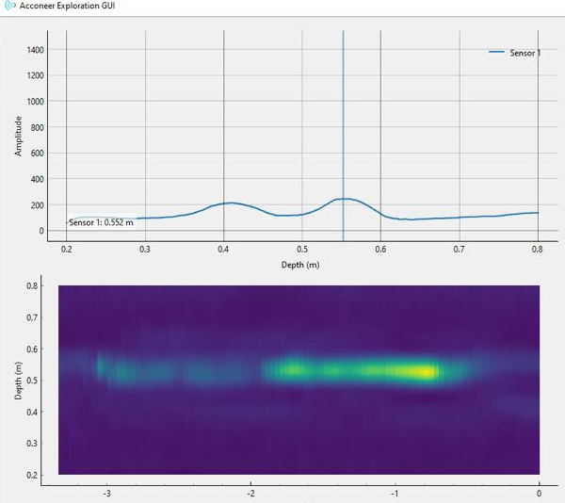

*Figure 4.1: No object detected.*

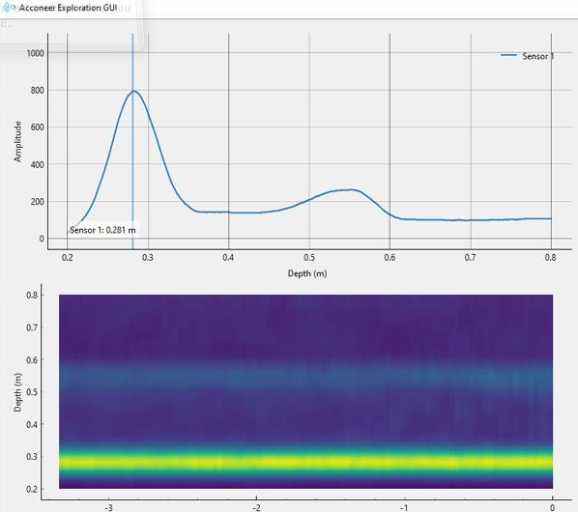

*Figure 4.2: Object detected at 0.281m.*

Acconeer's envelope service is designed to work effectively over long distances (as far as 7 meters in their testing) and low-precision situations. However, it may not be adequate for small scale motions like breathing motions of the chest. In such cases, the sensor provides an IQ (In phase Quadrature) service that serves the purpose for high-precision measurements.

### 4.1.2 The In-phase quadrature (IQ) service

The IQ service is specialized for phase measurements whereas envelope service estimates the envelope (amplitude) of the pulses that are reflected back to the radar.

The signal is divided into two components: in-phase I and quadrature Q components through IQ demodulation. Fig. 4.3 shows how a local oscillator is connected to each mixer with a phase difference of π/2 radians. This way, the amplitude and phase of the signal can be calculated.

The phase component is more sensitive to motions at a very micro level which causes more accuracy in readings where very small movements are involved. Therefore, the displacements of the chest, which can be as small as a mm value, can be effectively captured using IQ measurements.

The IQ service of Acconeer XM112 can take readings up to 1.0 m. However it consumes more power and requires more memory. We are willing to accept this trade-off for the measurement of breathing rate as it demands higher accuracy.

*Figure 4.3: Coherent I/Q demodulation, wo being the frequency of the local oscillator.*

### 4.1.3 Radar IQ data

IQ data is typically represented as a set of complex numbers, where the real part of each number represents the in-phase (I) signal and the imaginary part represents the quadrature (Q) signal. To obtain the complex representation, the I and Q signals are combined using the following formula.

In these equations, d is sample index and s is the sweep index.

𝑥 [𝑑, 𝑠] = 𝐼[𝑑, 𝑠] + 𝑗𝑄[𝑑, 𝑠] (4.2)

The sets of amplitude A [d, s] and phase ∅[𝑑, 𝑠] are calculated by the equations (4.3).

A[d, s] = 𝑎𝑏𝑠(𝑥*IQ*[𝑑, 𝑠])

 (4.3)

The sensor was pointed towards at the chest of a person. Fig. 4.5 shows the amplitude and phase plots when the person is breathing at a distance of 27 cm from the radar sensor.

*Figure 4.5: Amplitude and phase data.*

# 4.2 Signal processing

The IQ data from the radar module is sampled at 40 Hz. The data is then reshaped to separate the in-phase and quadrature-phase signals into separate arrays i and q. The envelope of the signal is calculated using the formula given in equation 4.3. A bandpass filter is applied to the envelope to remove noise and isolate the peaks corresponding to respiratory motion. Then we identify the peak values in the filtered envelope signal. The times at which these peaks occur are converted to breathing rates in breaths per minute.

Figure 4.6 shows the signal processing flowchart for extraction of breathing rate.

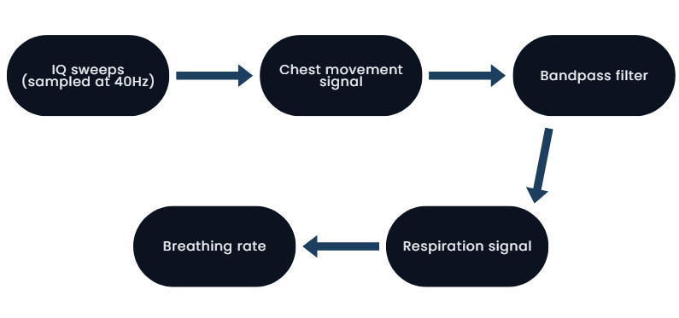

*Figure 4.6: Signal processing flowchart.*

# 4.3 Machine Learning Model

We are using the KNN classifier to classify the breathing rate as an adult’s or a child’s. The ML model is trained using google Colab and supporting libraries.

KNN (K-Nearest Neighbors) classifier is a supervised machine learning algorithm used for classification tasks. Given a dataset of labeled examples, the algorithm tries to predict the class of a new, unlabeled example by finding the k closest examples (i.e., the k nearest neighbors) to it in the feature space. The predicted class is then determined by majority vote among the k neighbors.

The key parameters of KNN are the number of neighbors k and the distance metric used to measure the similarity between examples. A common choice for the distance metric is Euclidean distance, but other metrics such as Manhattan distance or cosine similarity can also be used.

For our case, KNN (k-nearest neighbors) classifier with k=3 is created, and the training data is fit to the classifier. The code then uses the KNN classifier to predict the target label (adult or child) for the input breathing rate value. Finally, the predicted target label is printed.

*Figure 4.7: Decision boundary*

# 4.2 Breathing Rate detection

### 4.2.1 Extraction of Chest movement signal

The radar is placed withing the range of 0.2 - 0.8 m pointing towards the chest of the person whose breathing rate is to be measured. As discussed earlier, it provides us with a phase plot and an amplitude plot which is then processed.

*Figure 4.8: Chest movement signal*

### 4.2.2 Estimation of respiration rate

Our model applies the bandpass filter to the envelope, find the peaks, converts the frequency domain indices of peaks to time domain, calculates the breathing rate in breaths per minute by taking the inverse of the mean time difference between adjacent peaks and multiplying by 60.

breathing_rate = 60 / mean(diff(peak_times)) (4.4)

Chapter 5

# Implementation and Testing

# 5.1 System level diagram

Figure 5.1 shows the system level diagram of our project. It shows the functionality of different components and their relationship with different components in the system to perform its function.

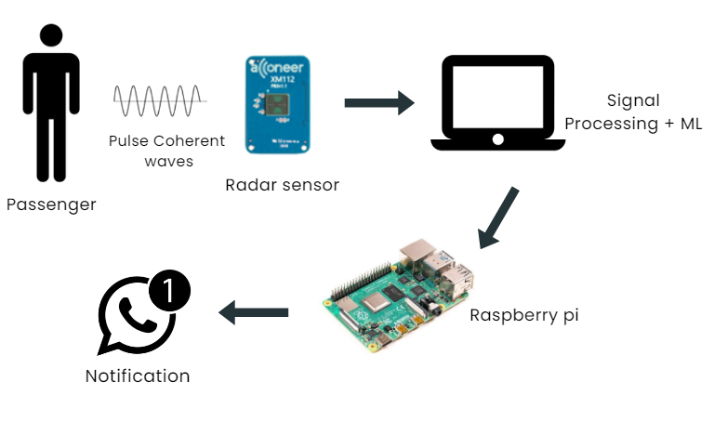

*Figure 5.1: System Level Diagram.*

# 5.2 Radar and supporting tools

After reviewing literature and evaluating specialties of different radars and a fair comparison of radars available in the industry like Radar Book, Acconeer’s XM112 radar sensor was selected for this project as its properties match better to our requirements.

Acconeer’s XM112 pulse coherent radar module, shown in Fig. 5.2 (a) sends out bursts of radar pulses instead of a continuous wave. Using the formulas discussed in 4.1.1, the distance and velocity of an object can easily be calculated by processing the pulses that return to the radar. This module is a pulsed coherent radar module with a printed circuit board of dimensions 24 mm x 16 mm including the A111 pulsed coherent radar and a 32-bit ARM® Cortex®-M7 ATSAME70Q20A CPU (PCB). It comes with a XB112 board.

It has several benefits. As the radar transmits EM waves for a segment of a period only, less energy is consumed as compared to a CW. This module allows mm-accuracy and high update rate frequency for improved precision.

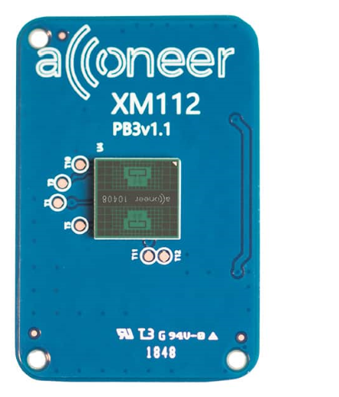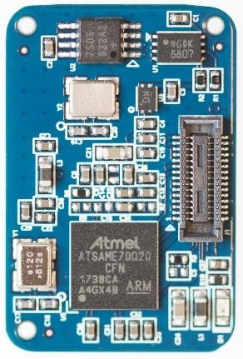

(a)

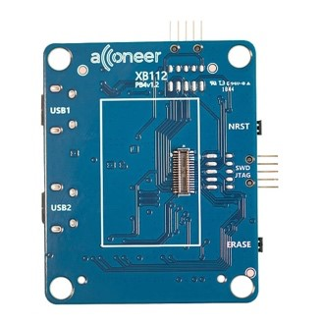

(b)

*Figure 5.2: (a) Xm112 radar (b) XB112 board*

The XB112 breakout board is used with XM112 to establish connections and for development purposes. It is used to flash the XM112 via USBUART.

Figure 5.3 shows two types of lenses, a cover and a lens holder.

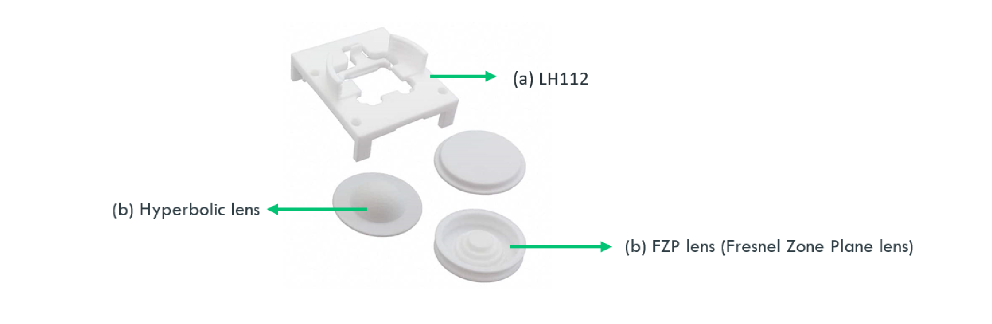

*Figure 5.3: LH112 lens and holders*

Lenses help achieve the best gain and a narrow beam.

We used the Acconeer Exploration tool to visualize the signal. Exploration tool is a graphical user interface (GUI). It consists of set of pre-programmed services and tools to perform data collection and development.

The connection between computer and module was made through seial connection through USB.

# 5.3 Further equipment and tools

The signal processing and ML classification is done on the raspberry pi 4 B. The Raspberry Pi is a computer run by Linux. It provides a set of general purpose input/output pins, through which you can attach and run further electronic components to allow you to explore the Internet of Things (IoT).

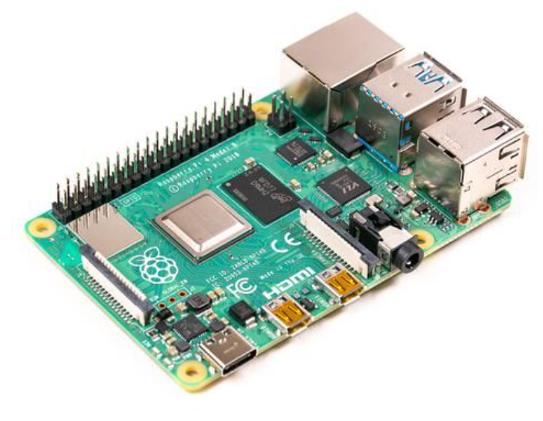

*Figure 5.4: Raspberry pi 4 B*

It comes with heatsinks and fan with a case to avoid overheating of the power IC.

# 5.4 Experimental setup

Our project setup includes a radar module (XM112), a matching breakout board (XB112) from Acconeer, lenses for the sensor along with a Raspberry Pi model 4B enclosed in a cardboard box. This box is then placed in front of the test subject to classify between children and adults.

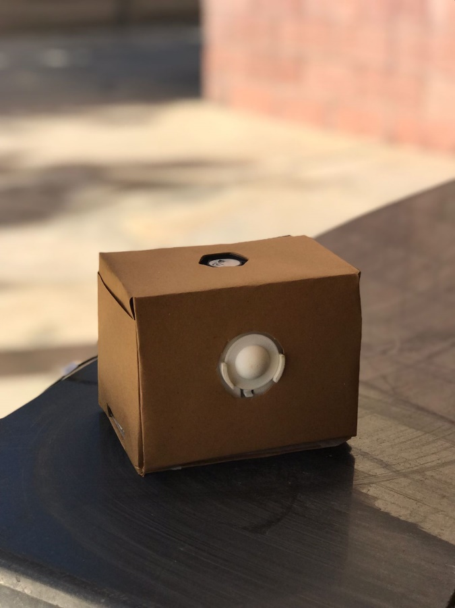

*Figure 5.4(a): Experimental Setup for SafeAuto*

*Figure 5.4(b): Experimental Setup for SafeAuto*

Using the "exploration tool" offered by Acconeer in the SDK, the In-phase and Quadrature components as well as the envelope of the signal were captured for data acquisition. This data was transferred to Google Colab for additional processing.

52 different subjects volunteered to give readings through radar, ranging from age of 6 months to 35 years, consent taken from the caregivers for children.

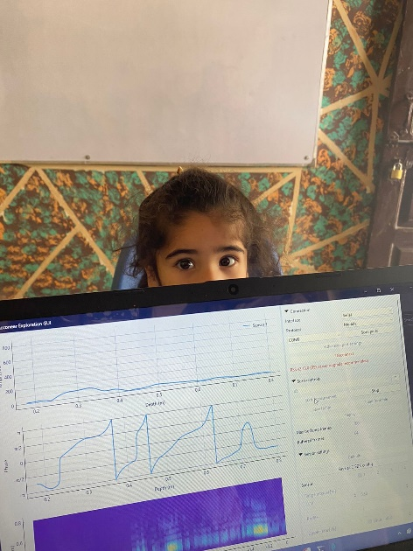

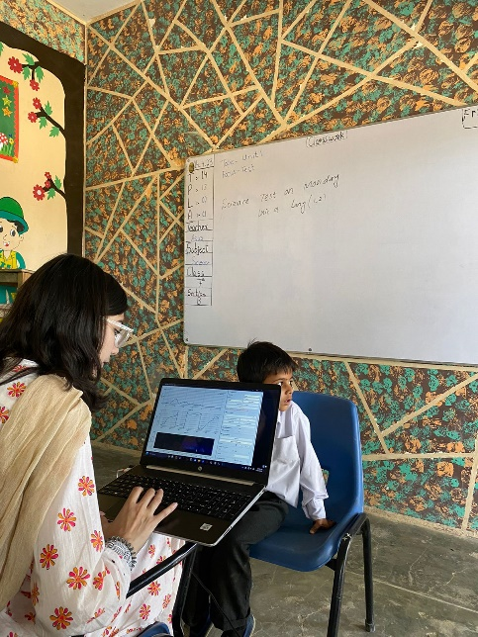

*Figure 5.5: Data collection and testing*

This experiment used a number of test subjects. The trial included 52 distinct participants, ranging in age from 0.6 years to 35 years. The post processing was done by google Colab and the Raspberry Pi was used for the runtime processing.

# 5.5 Control variables

To ensure the validity and precision of the outcomes obtained, various controlled variables were established and meticulously implemented during the testing process. A significant number of test subjects were necessary to produce reliable results.

In order to train the ML model, testing was carried out on 52 subjects which include 26 children, and 26 adults. For all subjects, the data was collected at rest position to measure the chest movements better. Table 5.1 shows range of respiration rates of children and adults as concluded by our testing data.

|  |  |
| --- | --- |
| Age | Breathing rate |
| Less than 5 years | 20.7 and above |
| Older than 5 years | Below 20.7 |

*Table 5.1:* *range of respiration rates for different ages.*

This project therefore distinguishes between two groups i.e. below 5, including toddlers and infants and above 5, including teenagers and adults.

The average distance between the radar and the subject is kept from 20 centimeters to 80 centimeters that is the average range of a seat of a car. Distance from the radar was varied in readings to ensure accuracy within range. All subjects being tested wore a single layer of clothing.

# 5.6 Statistical Analysis

The analysis approach progressed during the course of the project. Initially, the data acquisition tool was utilized to obtain the necessary signal data from the sensor. The tool leverages diverse processing methods such as envelope, power bins, sparse and IQ. To detect subtle movements accurately, in-phase and quadrature (IQ) service was selected. For additional analysis, the data was exported from the exploration tool to google colab in the form of an .h5 file. An H5 file, also known as an HDF5 file, is a file format used for storing and managing big and complex data collections. It is a binary file format that enables efficient storage and retrieval of data, and supports a wide variety of data types, including numerical, text, image, and audio data. H5 files are commonly used in scientific and engineering applications to store and exchange large amounts of data, such as in bioinformatics, climate modeling, and astrophysics. H5 files can be created and read using various software packages, including MATLAB, Python, and R.

Google Colab was chosen initially as it is the environment that we are already familiar with to train an ML model. Moreover, it can import libraries like numpy and matplotlib.pyplo for signal processing. The respiration rate estimation algorithm was implemented using functions like butter, filtfilt, find peaks and mean and correlation and MATLAB’s graphical tools like scatter were imported and implemented to plot decision boundary of the ML model to visualize the results better. The code written in Python on Colab was used in data collection of training as well as testing data.

Next, we used raspberry Pi for data processing.

# 5.7 Raspberry Pi

Raspberry Pi is used to implement signal processing and machine learning and to establish a connection to webserver to send a notification to the caregiver or whoever has the device installed in their vehicle.

# 5.8 Notifying the User

In our project, we are using wifi to notify the parent but using a GSM module would be more accurate.

# 5.9 Cost Analysis

|  |  |  |  |  |
| --- | --- | --- | --- | --- |
| **Item Name** | **Type** | **No. of Units** | **Per Unit Cost (in Rs)** | **Total (in Rs)** |
| Acconeer XM112 radar | Equipment | 1 | 18,137 | 18,137 |
| Lens | Equipment | 1 | 15,655 | 15,655 |
| Raspberry pi 4 | Equipment | 1 | 38,000 | 38,000 |
| Data Cable | Equipment | 2 | 250 | 500 |
| SD card and holder | Equipment | 1 | 940 | 940 |
| Heat sink | Equipment | 3 | 50 | 150 |
|  |  |  | **Total in (Rs)** | 73382 |

*Table 5.2:* *Costs.*

Chapter 6

# Results and Discussion

# 6.1 Percentage accuracy

Table 6.1 shows the breathing rate readings calculated using the radar and counting breaths manually for one minute for six of the test subjects. The readings were taken in the state of rest, each reading taken for 60 seconds with an update rate of 40 Hz. Hyperbolic lens was used to concentrate the beam towards the subject’s chest. The results show that the actual and reference values are very close i.e. all of them have percentage accuracy above 90%. The mean percentage accuracy is calculated to be 95.48%.

|  |  |  |  |
| --- | --- | --- | --- |
| **Subject** | **Breathing rate from radar** | **Breathing rate from manual counting** | **Percentage accuracy** |
| **1** | 20.68 | 20 | 96.6 |
| 20.46 | 19 | 92.315 |
| **2** | 19.85 | 19 | 95.526 |
| 18.97 | 19 | 99.842 |
| **3** | 16.21 | 17 | 95.352 |
| 18.23 | 18 | 98.72 |
| **4** | 14.57 | 14 | 95.928 |
| 20.21 | 21 | 96.238 |
| **5** | 20.67 | 19 | 91.210 |
| 16.51 | 17 | 97.117 |
| **6** | 17.48 | 16 | 90.750 |
| 15.39 | 16 | 96.188 |

*Table 6.1: Radar and manual readings of breathing rate.*

After signal processing, Colab gives us the results in the following form:



*Figure 6.1:* *Results of signal processing.*

After putting the calculated respiration rate through the trained KNN classifier, Colab gives us the results in the following form:



*Figure 6.2:* *Results of Machine Learning.*

The combined results on Google Colab after signal processing and machine learning are given as:

*Figure 6.3:Combined* *Results.*

# 6.2 GUI

Our results are then displayed on a GUI programmed on visual studio using python.

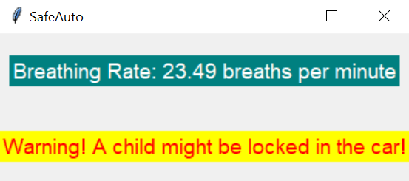

*Figure 6.4:GUI*

# 6.3 Text Alert

A text alert is generated to the user if a child is detected in the locked car. Twilio is used via visual studio for the implementation.

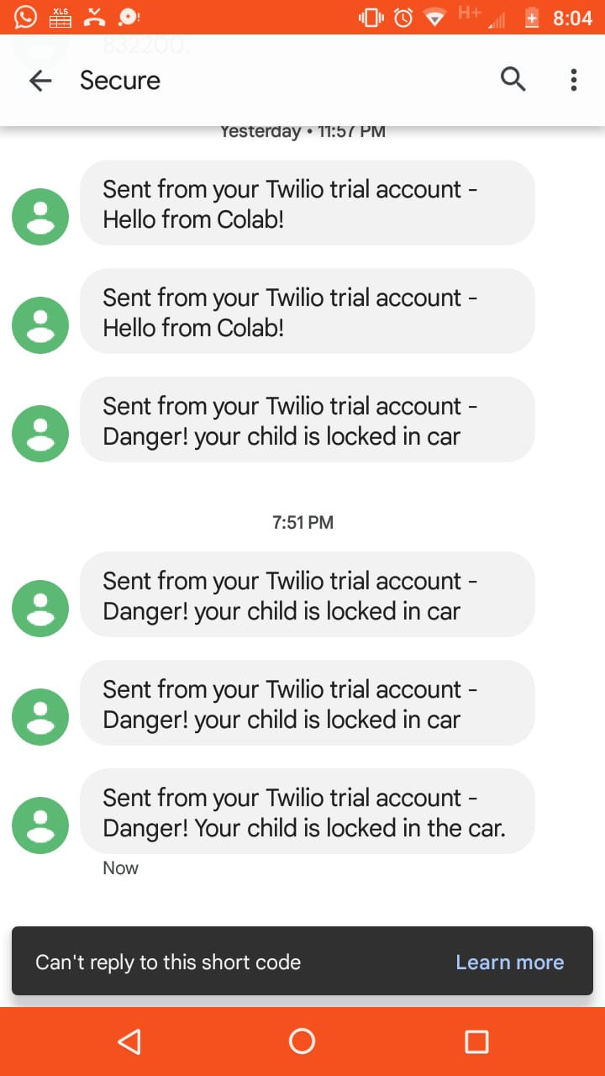

*Figure 6.5: Text Alert*

# Conclusion and Future Work

Through this project, we aimed at developing a device that would ensure child safety in a vehicle by ensuring a child is not trapped inside the cabin and is not prone to the risk of pediatric vehicular heatstroke in accordance with SDG 3 i.e. Ensuring healthy lives and promoting well-being for all at all ages. In addition, we also aimed at developing a working IoT infrastructure. The purpose was effectively achieved using millimeter-Wave radar technology, signal processing, machine learning tools and raspberry pi.

In order to achieve these deliverables, we used a 60 GHz short ranged pulsed radar. We used Raspberry Pi module to perform the real-time signal processing and to implement the IoT infrastructure. The chest movements are taken from the radar and are then reshaped to separate the in-phase and quadrature-phase signals. Then the envelope of the signal is calculated. A bandpass filter is designed to be applied to the envelope to remove noise and isolate the peaks corresponding to respiratory motion. The peak values in the filtered envelope signal are then identified and converted to breaths per minute. The breathing rate calculated by our model is accurate up to 95.48%.

For future work, this project an be extended to run Machine Learning algorithms for disease identification by monitoring breathing rates. Moreover, SafeAuto communicates to the user over WiFi, which consumes high amount of energy and has constraints like the need of availability of a network connection in case of an emergency situation of a child being trapped. Therefore, for future purposes, alternatives such as SMS or LiFi can be explored.

This project would promote facilitation of mass development not only in scenarios of child passenger safety, but also for other medical purposes like contactless breathing rate monitoring. Even though the risk of Covid-19 is now reduced to much extent, the pandemic as increased awareness of personal hygiene and personal space and has increased the value of contactless technology for day to day activities. This project can also be extended to pet health and safety in vehicles and in medical centers.

Chapter 8

# Appendix A

Signal processing Google Colab link: [signalprocessing](https://colab.research.google.com/drive/1YesePUmG0muqvwReTLGq25sigqGY6RMt?usp=sharing)

KNN ML classifier Google Colab link: [mlclassifier](https://colab.research.google.com/drive/1Dfra-ShxAWbPueqoJmAztb9vR9ObDy6L?usp=sharing)

Final code Google Colab link: [finalcode](https://colab.research.google.com/drive/1-C_bDK_wzef8GUSwBwwIhKEuPUsRhoxO?usp=sharing)

Chapter 9

# References

Alizadeh, M., Shaker, G., Almeida, J., Morita, P., & Safavi‐Naeini, S. (2019). Remote Monitoring of Human Vital Signs Using mm‐Wave FMCW Radar. *IEEE Access*, 54958–54968.

Huey-Ru Chuang, H.-C. K.-L.-H.-S.-W. (2012). 60-ghz millimeter-wave life detection system (mlds) for noncontact human vital-signal monitoring. . *Sensors Journal, IEEE,*, 602 – 609.

Lees, M. (1989). Digital beamforming calibration for FMCW radar. *IEEE Trans. Aerosp. and Electron. Syst*, 281–284.

Lin, J., & Salinger, J. (1975). Microwave measurement of respiration. *1975 IEEE MTT‐S*, (pp. pp. 285– 287.).

M. Alizadeh, G. S.-N. (2019). Remote monitoring of human vital signs using mm-wave fmcw radar. *IEEE Access,*, 54958–54968.

Nosrati, M., Shahsavari, S., Lee, S., Wang, H., & Tavassolian, N. (2019). A Concurrent Dual‐Beam Phased‐Array Doppler Radar Using MIMO Beamforming Techniques for Short‐Range Vital‐Signs Monitoring. *IEEE Trans. Antennas Propag.*, 2390–2404.

Peng, Z., Munoz‐Ferreras, J., Tang, Y., Liu, C., Gomez‐Garcia, R., Ran, L., & Li, C. (2017). A Portable FMCW Interferometry Radar With Programmable Low‐IF Architecture for Localization, ISAR Imaging, and Vital Sign Tracking. *IEEE Trans. Microw. Theory Tech.*, 1334–1344.

Sakamoto., T. (2019). Noncontact measurement of human vital signs during sleep using low-power millimeter-wave ultrawideband mimo array radar. *In 2019 IEEE MTT-S International Microwave Biomedical Conference (IMBioC)*, (pp. 1–4).

Santra, A., Ulaganathan, R., & Finke, T. (2018). Short‐Range Millimetric‐Wave Radar System for Occupancy. *IEEE Sensors*, 1–4.

Wang, G., Munoz‐Ferreras, J.‐M., Gu, C., Li, C., & Gomez‐Garcia, R. (2014). Application of LinearFrequency‐Modulated Continuous‐Wave (LFMCW) Radars for Tracking of Vital Signs. *IEEE Trans. Microw. Theory Tech.*, 1387–1399.

Zhicheng Yang, P. P. (2016). Monitoring vital signs using millimeter wave. 211–220, .

*Figure 3.2 Details of the I-Q demodulator. The digitized (sampled and. . .* (n.d.). ResearchGate. <https://www.researchgate.net/figure/Details-of-the-I-Q-demodulator-The-digitized-sampled-and-A-D-converted-signal-Ue-is_fig4_267239380>

*Raspberry Pi 4 Model B 1GB, 2GB, 4GB, 8GB*. (n.d.). https://instock.pk/raspberry-pi-4-model-b-1gb-2gb-4gb.html

https://www.pampersprofessional.com/sfsites/c/resource/PDF_vehicular_heatstroke_July2022

*What Is Vehicular Heatstroke - Bag In The Back*. (n.d.). Bag in the Back. <https://bagintheback.org/what-is-vehicular-heatstroke-and-causes/>

*Heatstroke|NHTSA*.(n.d.).NHTSA.https://www.nhtsa.gov/campaign/heatstroke#:~:text=When%20a%20child%20is%20left,died%20of%20heatstroke%20in%20vehicles

No Heat Stroke. (n.d.). https://noheatstroke.org/